Ahavah BBG #331
February Edition

As of late January, our chapter has gone into a NEW term with a NEW board and NEW info!!! Welcome 2012 and bring on the NEW term!

What’s in this edition? Check it out:
- What’s NEW with Winnie the Jew
- Upcoming Events
- Games & Comics

Submitted with Undying love for…
The 2012 Spring/Summer chapter board, prom dress shopping, the oxford comma, The Woman in Black, RMR Rush 2012: Skate City, Kallah 2012, and all of you amazing BBG girls, I remain your DARN proud Mazkirah,
Rachel Winston

What’s NEW!?!
- The chapter website has been updated and you all should check it out! Go to http://ahavahbbg331.weebly.com/uploads/8/6/8/2/8682271/ahavah_bbg_november_newspaper.pdf

- Say hello to the new board;
  - N’Sia: Keren Megory
  - S’ganit: Heather Greenstien
  - Yehudiah: Eliana Goldtein
  - Mit Mom: Joey Hielman
  - Gizborit: Kate Dow
  - Mazkirah: Rachel Winston
  - Rackazit: Olivia Davis
*** Installations were on Thursday, February 2nd

- This past Thursday, the board got together for dinner to plan the upcoming term’s calendar! After eating pesto chicken, salad, fruit, and challah bread, we sat down and came up with some awesome programs which are listed in the following.

Upcoming Events:
- The countdown to IC continues!! 331 is proud to have one of our own – Keren Megory, in attendance. We all hope you have a great time!
- Let’s hear it for the BBG Calling Tree! This Thursday during meetings, both we and the boys of 380 will all sit down with a HUGE list of prospect member that we will go through, call, and assign a calling tree for future contacts.
- Don’t forget that AIT/MIT is on the weekend of March 2nd. Scheduling and information will soon be available on the facebook page.
- INSTALLATIONS are just around the corner! Ahavah girls get ready for the night of your life! March 10th -11th, we will be having this term’s installations ceremony at Heather’s house. While there, we will install the new members, have the first good and welfare of the terms, and (most likely) have another 331 style dance party. In the morning, we will all bus down to DENVER to go to Jump Street with Denver’s 6 and Fort Collins.
- Mark your calendars; the second annual Paint War with 1210 will be on Saturday, March 17th! For those of you who were not able to attend last year, we hope you u can make it because this is the program to be at!
- April showers bring May flowers… and our first philanthropy project of the term. Saturday, April 7th, we will be having a food drive fundraiser to help a local organization (maybe the teen homeless shelter??).
- Kallah 2012. Nough’ said. This year, Kallah will be the weekend of Friday, April 20th. More information is soon to come but in the meantime, make sure to check out the facebook event page: http://www.facebook.com/events/162811800494084/.
- Sunday, April 29th is… KEREN’S BIRTHDAY!!! and our night on the town with 380! We’ll be going to the Grizzly Rose for a fun night out!
- As the year comes to an end, we must not forget senior appreciation (the best program!!) which will be on Sunday, May 6th. More information is on its way.

For fun:
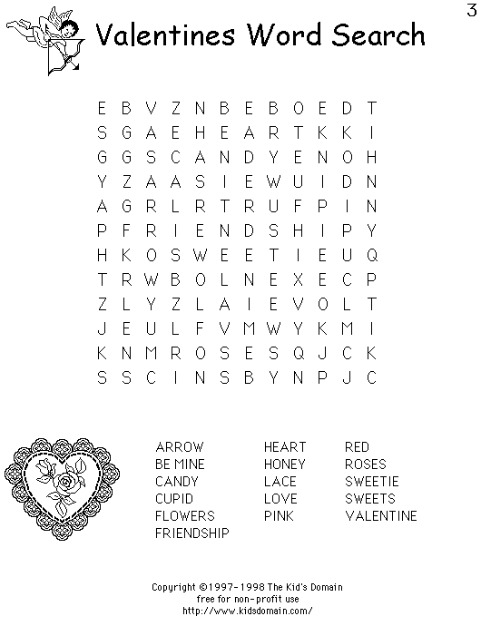

PS – Go see The Vow TONIGHT (Thursday) at 6:30 at Century Theater! <3 Channing Tatum!!!

